1.INTRODUCTION

1.1 OVERVIEW

The sweets industry,also known as the confectionery industry,involves the production and sale of various sweet treats, such as candies, chocolates,gum,and other sugary products. Keerthi sweets facility relies in customer billing and invoicing.They can customer services fees,and manage payments,and generate statements for patients.Zoho books helps them maintain financial transparency and ensures efficient billing process  
[2.PROBLEM](http://2.problem/)  
    [2.1](tel:2.1) Empathy ap

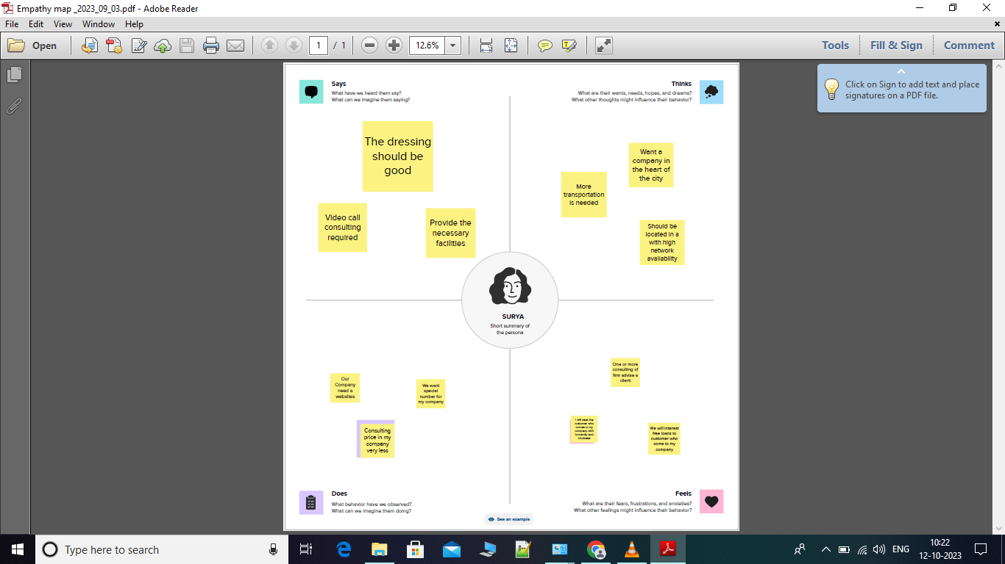

2.2 BRAINSTORM & IDEA PRIORITATION

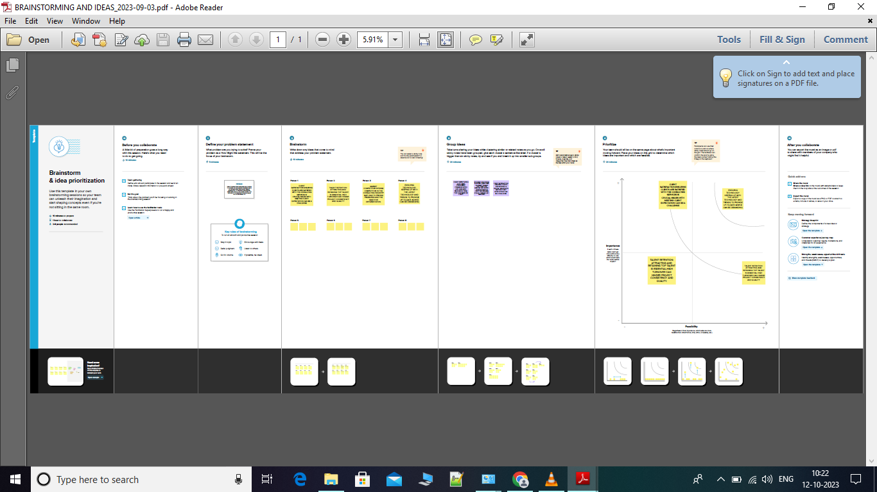

[3.RESULT](http://3.result/):  
    Output  
The output of profit and loss for gokul Zoho Company from 01/04/[2023](tel:2023) To 30/04/[2023](tel:2023) with the profit of rs.1,14,500   
      The balance sheet as on 08/05/[2023](tel:2023) with the Total Assets and  the Total Liabilities of rs.2,23,050

PROFIT AND LOSS

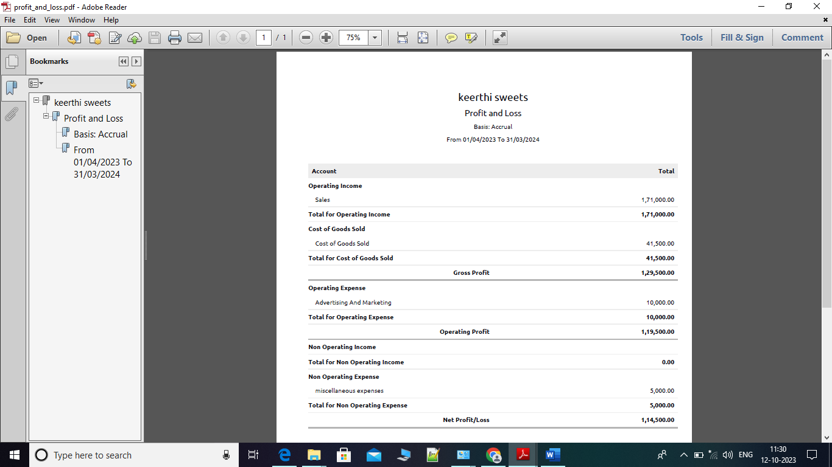

BALANCE SHEET

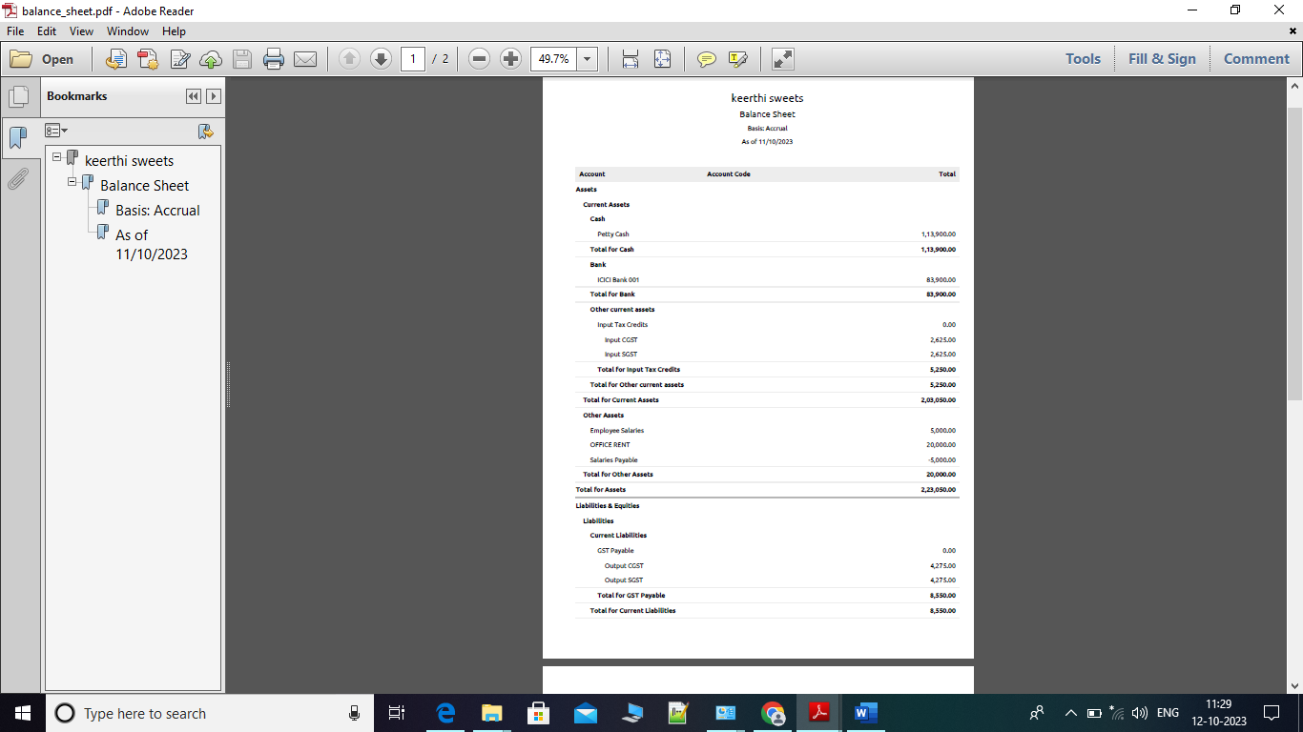  
  
  
[4.ADVANTAGES](http://4.advantages/) & DISADVANTAGES:  
    Advantages  
¬ Manage different aspects of sweets shop operations efficiently with easy access to critical customer information.  
¬ Create easily customizable and user-friendly forms to quickly gather customer information.  
¬ Maintain all the  customer records securely with improved accessibility, and manage them all in one place.  
    Disadvantages  
¬ It does have a certain level of complexity that may not be suitable for businesses with limited technical expertise. This could impact the ease of implementation and adoption.  
¬ All Zoho Books plans set a maximum number of invoices you can issue per year. Zoho Books also lacks features for calculating any type of tax other than sales tax.  
¬ Difficult to balance your personal life. Full-time employment can be rigorous, requiring your full commitment for most of the week (normally 40 hours from 9 am to 5 pm).  
  
[5.APPLICATIONS](http://5.applications/):  
¬ This solutions can be applied in the areas of all CANDY industires to track medical service fees,manage insurance payments and statements of patients.  
[6.CONCLUSION](http://6.conclusion/):   
¬ Preparation and maintanence of zoho books for health CANDY defines the invoicing and [payments.It](http://payments.it/) also maintains the financial transparency with the profit and loss accounts and balance sheet.  
[7.FUTURE](http://7.future/) SCOPE:  
¬ It allows you to manage your projects from budgeting to logging time and invoicing customers effectively. Moreover, Zoho Books Software lets you record the time spent on tasks and avoid overbilling and underbilling your customers